- INTRODUCTION:
Hypothyroidism refers to the common pathological condition of thyroid hormone deficiency. If untreated, it can lead to serious adverse health effects and ultimately death. Because of the large variation in clinical presentation and general absence of symptom specificity, the definition of hypothyroidism is pre-dominantly biochemical. Overt or clinical primary hypothyroidism is defined as thyroid-stimulating hormone (TSH) concentrations above the reference range and free thyroxine concentrations below the reference range. Mild or subclinical hypothyroidism, which is commonly regarded as a sign of early thyroid failure, is defined by TSH concentrations above the reference range and free thyroxine concentrations within the normal range. Subclinical hypothyroidism has been reviewed in a previous Lancet Seminar1 and is therefore not the focus here.
Whether the existing reference ranges of TSH and free thyroxine should be used to define thyroid dysfunction is a matter of debate. This issue is of clinical importance because the reference ranges are generally used as a threshold for treatment. Thyroid hormone replacement with levothyroxine is the standard treatment for patients with hypothyroidism. However, a substantial proportion of patients treated with levothyroxine have persistent complaints despite reaching the biochemical therapy targets, which has prompted the question of whether levothyroxine treatment is sufficient for all patients or whether alternative therapies (eg, combination with liothyronine preparations) could be adopted. Hypothyroidism in children and pregnant women are considered separate topics and have been discussed elsewhere.
The last part of the 19th century was a period of great achievements in medicine and endocrinology. The thyroid gland evolved from being considered a rudimentary structure to an organ related to specific diseases. The singular importance of iodine became acknowledged. Graves-Basedow's disease was described. Surgical treatment evolved with extraordinary speed. Theodor Kocher observed that the clinical picture in patients after total thyroidectomy was similar to the one seen in cretinism. In 1850, the first case of hypothyroidism or myxedema was described. Less than 50 years later, effective treatment was introduced. Another 50 years later, autoimmune thyroiditis was ascertained as the most frequent cause of hypothyroidism (in areas with no iodine deficiency). This paper gives a short survey of the history of hypothyroidism and its treatment^{.[1]}
Levothyroxine helps regulate the body's metabolism, energy production, and other essential physiological functions by being converted into its active form, triiodothyronine (T3), in peripheral tissues.
It is also used in suppressive therapy for thyroid cancer and goiters.
Levothyroxine is a synthetic form of the thyroid hormone thyroxine (T4), used to treat hypothyroidism (an underactive thyroid). It works by replacing or supplementing the natural thyroid hormone that the body is not producing in sufficient amounts. This helps regulate metabolism, energy levels, and various bodily functions. Levothyroxine is typically taken orally in the form of tablets or liquid and is adjusted based on the individual's thyroid hormone levels, which are monitored regularly by a healthcare provider. It's one of the most commonly prescribed medications for thyroid disorders^{.[2]}
Epidemiology:
The prevalence of overt hypothyroidism in the general population varies between 0–3% and 3–7% in the USA and between 0–2% and 5–3% in Europe,4–8 depending on the definition used. A meta-analysis7 of studies across nine European countries estimated the prevalence of undiagnosed hypothyroidism, including both overt and mild cases, at around 5%. Differences in iodine status affect the prevalence of hypothyroidism, which occurs more frequently both in populations with a relatively high iodine intake and in severely iodine-deficient populations.9,10 Hypothyroidism occurs more frequently in women, in older people (>65 years), and in white individuals, although data on ethnic differences are scarce. Hypothyroidism is more common in patients with autoimmune diseases, such as type 1 diabetes, autoimmune gastric atrophy, and coeliac disease, and can occur as part of multiple autoimmune endocrinopathies. Individuals with Downs’ syndrome or Turners’ syndrome have an increased risk of hypothyroidism. By contrast, tobacco smoking and moderate alcohol intake are associated with a reduced risk of hypothyroidism^{.[3]}

- OBJECTIVBES:
The aims of treatment are to alleviate symptoms, align thyroid function tests within or close to the reference range, and to reduce the risk of long-term complications.

- PATHOPHYSIOLOGY:
The most common cause of hypothyroidism is the inability of the thyroid gland to produce a sufficient amount of thyroid hormone; however, less commonly, pituitary and hypothalamus impairment may also result in thyroid dysfunction. The hypothalamus secretes thyrotropin-releasing hormone (TRH) that stimulates the pituitary gland to produce thyroid-stimulating hormone (TSH). Thyroid-stimulating hormones stimulate the thyroid gland to produce and secrete mainly T4, approximately 100 to 125 nmol daily, and smaller quantities of T3. The half-life of T4 is 7 to 10 days, and eventually, T4 is converted to T3 peripherally by 5'-deiodination. Negative feedback on the production of TRH and TSH is exerted primarily by T3 and, to some extent, T4. Alteration in the structure and function of any of these organs or pathways can result in hypothyroidism.[16] Additionally, the decline in the production of T4 results in an increase in the secretion of TSH by the pituitary gland, causing hypertrophy and hyperplasia of the thyroid parenchyma, thereby leading to increased T3 production^{.[4]}
Types of hypothyroidism:
Primary Hypothyroidism:
In iodine-sufficient areas, the most common cause of hypothyroidism is chronic autoimmune thyroiditis (also known as Hashimoto’s disease). High concentrations of anti-thyroid antibodies (predominantly thyroid peroxidase antibodies and anti-thyroglobulin antibodies) are present in most patients with autoimmune thyroiditis. Raised concentrations of thyroid peroxidase antibodies are also detected in about 11% of the general population.8 In patients with subclinical hypothyroidism, thyroid peroxidase antibody measurements help to predict progression to overt disease. The exact mechanisms underlying autoimmune thyroiditis are not known, but both genetic and environmental factors are involved. A higher genetic risk score—calculated using five genetic variants for thyroid peroxidase antibodies identified by genome-wide association studies—showed a graded association with higher TSH concentrations and clinical hypothyroidism. Smokers have lower thyroid peroxidase antibody concentrations than non-smokers, and incidence of autoimmune thyroiditis increases after smoking cessation. Other environmental factors implicated in autoimmune thyroiditis are vitamin D and selenium deficiency, and moderate alcohol intake.^{[5]}
Iodine is an essential component of thyroid hormone. Iodine deficiency can result in goitre, thyroid nodules, and hypothyroidism. The most severe consequence of iodine deficiency is cretinism (ie, restricted mental and physical development in utero and during childhood). Iodine fortification programmes are one of the safest and cheapest public health interventions for the prevention of cognitive and physical impairment. Despite such efforts, suboptimal iodine status still affects large parts of Africa and Asia, as well as specific subpopulations in several high-income countries—most notably, pregnant women in some areas of Italy, USA, and the UK. In populations that shift from severe to mild iodine deficiency, the prevalence of hypothyroidism decreases; in populations shifting from mild deficiency to optimum or excessive intake of iodine, the prevalence of autoimmune hypothyroidism increases.
Iodine-containing drugs (eg, amiodarone) can restrict thyroid hormone production through iodine overload, immediately blocking thyroid hormone synthesis (ie, Wolff-Chaikoff effect). About 14% of patients treated with amiodarone develop hypothyroidism. Lithium also causes hypothyroidism via effects on thyroid hormone synthesis and release. In a large population-based cohort study, 6% of patients needed levothyroxine therapy within 18 months of starting lithium treatment. Tyrosine kinase inhibitors are used as targeted therapy for several cancers. An analysis of clinical reports from the US Food and Drug Administration Adverse Event Reporting System, found that patients who received sunitinib developed hypothyroidism more frequently than patients treated with sorafenib. Several other drugs—including interferon-alfa, thalidomide, some monoclonal antibodies, antiepileptic drugs, and drugs for second-line treatment of multidrug-resistant tuberculosis—can also cause primary hypothyroidism (panel).
Hypothyroidism is common after radioiodine treatment, after hemithyroidectomy, and after neck radiation or surgery for cancer therapy. In the long term, about 80% of patients with Grave’s disease who are treated with radioiodine will develop hypothyroidism, even when low doses are used. Hypothyroidism is reported to occur in 55% of patients treated for toxic nodular goitre40 and about 8% of patients treated for solitary toxic nodules.In a meta-analysis43 of 32 studies, 20% of patients developed hypothyroidism after hemithyroidectomy. Other causes of primary hypothyroidism include transient thyroiditis and infiltrative disease (panel).
Central Hypothyroidism:
Central hypothyroidism is rare and affects both sexes equally. It is more often associated with pituitary than hypothalamic disorders but frequently involves both. Biochemically, central hypothyroidism is defined by low or low-to-normal TSH concentrations and a disproportionately low concentration of free thyroxine. Occasionally, TSH concentration is mildly elevated, probably because of decreased bioactivity. Over half of central hypothyroidism cases are caused by pituitary adenomas. Other causes of central hypothyroidism include pituitary or hypothalamic dysfunction due to head trauma, pituitary apoplexy, Sheehan’s syndrome, surgery, radiotherapy, genetic, and infiltrative disease. Several drugs are known to affect the hypothalamic–pituitary–thyroid axis (panel^{).[6]}
Peripheral Hypothyroidism:
Consumptive hypothyroidism is caused by aberrant expression of the deiodinase 3 enzyme (which inactivates thyroid hormone) in tumour tissues. Although very rare, such overexpression can induce severe hypothyroidism. Elevated concentration of deiodinase 3 was first described in a newborn baby with infantile hepatic haemangiomatosis, but can also occur in patients with vascular and fibrotic tumours and gastrointestinal stromal tumours. Patients with rare genetic syndromes that lead to a reduced sensitivity to thyroid hormone (panel) usually have normal TSH concentrations, but can also present with tissue-specific hypothyroidism^{.[7]}
Histopathology:
Autoimmune thyroiditis causes an increase in the turnover of iodine and impaired organification. Chronic inflammation of the parenchyma leads to predominant T-cell lymphocytic infiltration. If this persists, the initial lymphocytic hyperplasia and vacuoles are replaced by dense fibrosis and atrophic thyroid follicles. Coexisting or associated malignancies, such as papillary thyroid cancer, can also be seen^{.[8]}
Etiology:
Hypothyroidism is primarily categorized as primary and secondary (ie, central) hypothyroidism. In primary hypothyroidism, the thyroid gland cannot produce adequate amounts of thyroid hormone. The less commonly seen secondary or central hypothyroidism occurs when the thyroid gland functions normally; however, hypothyroidism results from the abnormal pituitary gland or hypothalamus function.
The most prevalent etiology of primary hypothyroidism is an iodine deficiency in iodine-deficient geographic areas worldwide. Autoimmune thyroid diseases are the leading causes of hypothyroidism in the iodine-sufficient regions. Hashimoto thyroiditis is the most commonly seen etiology in the US and has a strong association with lymphoma. Hypothyroid etiology can be influenced locally by iodine fortification and the emergence of new iodine-deficient areas. ^{[9]}
Risk Factors:
- Being assigned female at birth (AFAB)
- Autoimmune disease
- Genetic predisposition (a biological parent or sibling with the condition)
- History of thyroid surgery, including thyroid gland removal

- Hypothyroidism Sign and symptoms may include:
- Tiredness.
- More sensitivity to cold.
- Constipation.
- Dry skin.
- Weight gain.
- Puffy face.
- Hoarse voice.
- Coarse hair and skin.
- Muscle weakness.
- Muscle aches, tenderness and stiffness.
- Menstrual cycles that are heavier than usual or irregular.
- Thinning hair.
- Slowed heart rate, also called bradycardia.
- Depression.
- Memory problems ^{[10]}

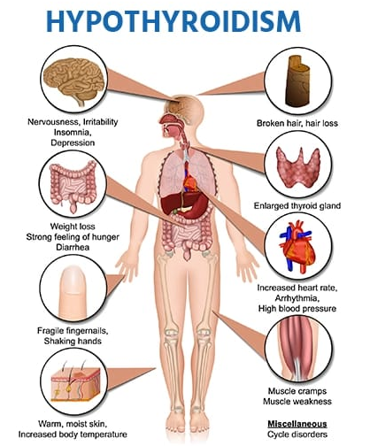
Figure 1: Hypothyroidism ^{[10]}

DIAGNOSIS:
The symptoms of hypothyroidism can be different from person to person. And they often look like symptoms of other health problems. Because of that, a diagnosis of hypothyroidism doesn't rely on symptoms alone. It's usually based on the results of blood tests.
The first blood test typically done to diagnose hypothyroidism measures the level of thyroid-stimulating hormone (TSH) in the blood. If it's high, the test is done again, along with a blood test for the thyroid hormone T-4. If the results show that TSH is high and T-4 is low, then the diagnosis is hypothyroidism. In some cases, the thyroid hormone T-3 may be measured as well.
If the second test shows high TSH but T-4 and T-3 are in the standard range, then the diagnosis is a condition called subclinical hypothyroidism. It usually doesn't cause any noticeable symptoms.
TSH tests also play an important role in managing hypothyroidism over time. They help your health care provider find and maintain the right dosage of medication for you.
The results of these blood tests can be affected by some medicines or supplements. This includes biotin, a vitamin taken as a stand-alone supplement or as part of a multivitamin. Before you have blood tests done, tell your health care provider about any medicines or supplements^{.[11]}

- TREATMENT:
Hypothyroidism is usually treated with levothyroxine, a synthetic form of the thyroid hormone thyroxine (T4). The goal is to normalize thyroid hormone levels and alleviate symptoms. Below is a summary of the treatment and considerations:
1. Medication
Levothyroxine (Synthroid, Levoxyl, Euthyrox, etc.)
Taken orally once daily, usually in the morning on an empty stomach.
Dosage is individualized based on factors such as age, weight, severity of hypothyroidism, and comorbid conditions.
Regular monitoring of thyroid-stimulating hormone (TSH) levels is essential to adjust the dose.
2. Monitoring
TSH and free T4 levels are checked:
Every 4-6 weeks initially until stable.
Every 6-12 months thereafter or sooner if symptoms recur or the dose is changed.
Symptoms such as fatigue, weight changes, or cold intolerance may indicate the need for dosage adjustment.
3. Lifestyle Considerations
Diet: Maintain a balanced diet. Avoid excessive iodine intake, as it can interfere with thyroid function.
Space out levothyroxine from calcium or iron supplements and high-fiber foods by 4 hours, as these can affect absorption.
Weight management: A healthy diet and regular exercise help manage weight, which can be challenging with hypothyroidism.
4. Special Populations
Pregnancy: Thyroid hormone requirements often increase during pregnancy. Regular monitoring and dose adjustment are crucial.
Elderly: Start with a lower dose to avoid heart-related side effects.
5. Complementary Therapies
Desiccated thyroid extract (e.g., Armour Thyroid): Derived from animal thyroid glands, used in some cases, but not recommended as first-line treatment due to inconsistent hormone levels.
Supplements should only be taken under a doctor’s supervision.
6. When to Seek Help
If symptoms persist despite treatment.
Signs of over-replacement, such as palpitations, anxiety, or weight loss.
Consult with an endocrinologist or primary care physician for tailored management^{.[12]}
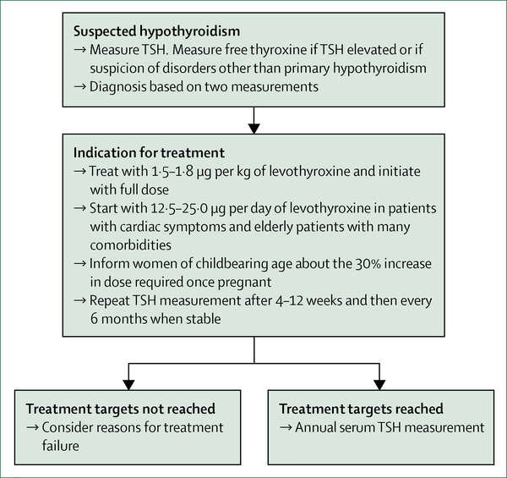

Figure 2: Treatment Chart ^{[12]}

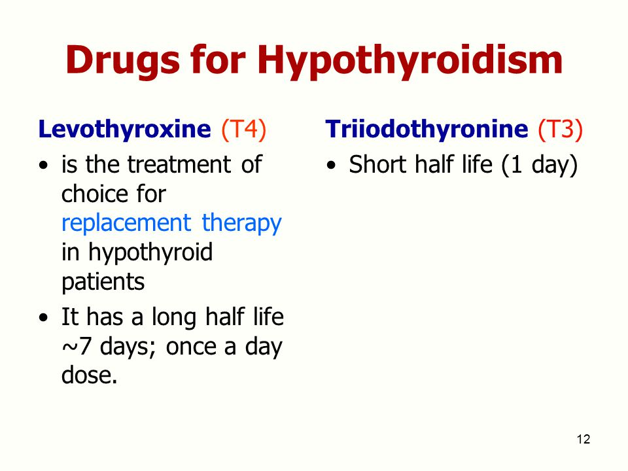
- CLASSCIFICATION OF DRUG:

Figure 3: Classification Chart ^{[13]}

LEVOTHYROXINE DRUG:
INDICATIONS:
Oral levothyroxine is FDA approved for treating primary, secondary, and tertiary hypothyroidism. Primary hypothyroidism is due to a problem in the thyroid gland, with the most common cause being an autoimmune condition (Hashimoto thyroiditis) and iatrogenic hypothyroidism (after thyroidectomy). Secondary hypothyroidism is when the problem is in the pituitary gland (from pituitary adenomas to post-surgical intervention), and there is a decrease in thyroid-stimulating hormone (TSH) production. Tertiary hypothyroidism is rare, and the problem is in the hypothalamus with decreased production of a thyroid-releasing hormone (TRH).
Additionally, levothyroxine has FDA approval for pituitary thyrotropin suppression as an adjunct to surgery and radioiodine therapy to manage thyrotropin-dependent well-differentiated thyroid cancer. Injectable levothyroxine is FDA approved for the treatment of myxedema coma or severe hypothyroidism.
Off-label usage of levothyroxine includes cadaveric organ recovery and subclinical hypothyroidism. Subclinical hypothyroidism with TSH >10 mIU/L and symptomatic patients should be treated with levothyroxine therapy. ^{[14]}

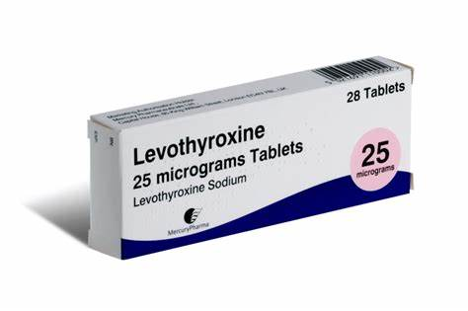
Figure 4: Levothyroxine Tablet

Mechanism of Action:
Levothyroxine(T4) is a synthetic version of the body’s natural thyroid hormone: thyroxine(T4). Normally, the hypothalamus secretes thyrotropin-releasing hormone(TRH), which then stimulates the anterior pituitary to secrete thyroid-stimulating hormone(TSH), which subsequently stimulates the thyroid to secrete 80% thyroxine (T4) and 20% L-triiodothyronine(T3). Fifty percent of thyroxine (T4) then gets converted to its active metabolite L-triiodothyronine (T3). The thyroid hormones then work by binding to thyroid receptor proteins contained within the cell nucleus.
Once inside the nucleus, thyroid hormones directly influence DNA transcription to increase body metabolism by increasing gluconeogenesis, protein synthesis, the mobilization of glycogen stores, and other functions. In scenarios where this process is interrupted (as seen in primary, secondary, or tertiary hypothyroidism), levothyroxine (LT4) can mimic the body’s endogenous T4 production by the thyroid.^{[15]}
Pharmacokinetics:
Absorption: Orally administered levothyroxine is absorbed from the jejunum and upper ileum (40% to 80%). The relative bioavailability of levothyroxine tablets, compared to an equal dose of oral levothyroxine solution, is approximately 93%. Levothyroxine absorption is increased by fasting and is decreased in the presence of food and malabsorption syndromes. Dietary fiber reduces the bioavailability of T4.
Distribution: Thyroid hormones are greater than 99% bound to plasma proteins, including thyroxine-binding globulin (TBG), thyroxine-binding prealbumin (TBPA), and albumin (TBA). T4 has a greater affinity for TBG and TBPA, leading to slower metabolic clearance and a longer half-life of T4 than T3. The free hormone is metabolically active. Many drugs and physiologic conditions alter the binding of thyroid hormones to serum proteins.
Metabolism: Thyroid hormones are primarily metabolized by sequential deiodination. Approximately 80% of T3 derives from peripheral T4. The liver is the primary site of degradation for T4 and T3, with T4 deiodination also occurring at several additional sites, including the kidney. T4 is deiodinated to generate an equal quantity of T3 and reverse T3 (rT3). T3 and rT3 are then deiodinated to diiodothyronine. Thyroid hormones are also metabolized via conjugation and undergo enterohepatic recirculation.
Excretion: The kidneys primarily excrete thyroid hormones. Approximately 20% of T4 is excreted in the stool. Urinary excretion of T4 decreases with age.^{[16]}

Adverse Effects:
Generally, adverse events resulting from incorrect dosing (excessive dosing) often form a hyperthyroid-like picture or an allergic reaction to the excipient of the levothyroxine tablets. Levothyroxine 50 mcg tablets don't contain allergic excipients, so there is a decreased risk for immune reactions. Allergy to the excipients such as dye(tartrazine yellow), lactose, acacia, or even gluten in the levothyroxine tablet may infrequently occur. Hence, allergy or intolerance to levothyroxine can be managed by changing the product, including consideration of gel capsules. Among older persons treated with levothyroxine, levothyroxine at doses more than 75 mcg per day is associated with an increased risk of atrial fibrillation.
Adverse Drug Reactions (According to System Organ Classification)
Cardiovascular Adverse Drug Reactions
- Angina pectoris
- Tachycardia
- Palpitations
- Arrhythmia
- Myocardial infarction
- Atrial fibrillation
Neuropsychiatric Adverse Drug Reactions
- Anxiety
- Insomnia (advise the patient to take levothyroxine in the morning)
Gastrointestinal Adverse Drug Reactions
- Weight loss
- Fatigue
- Diarrhea
- Emesis
Dermatological Adverse Drug Reactions
- Skin rash
- Alopecia
- Diaphoresis
Endocrine Adverse Drug Reactions
- Goiter
- Menstrual irregularities
- Heat intolerance
- Decreased bone mineral density (a result of TSH suppression)
Hepatic Adverse Drug Reactions
- Increased liver enzymes (hepatocellular or mixed pattern)
- Immunoallergic hepatitis (with eosinophilia) ^{[17]}
Drug Interactions:
Levothyroxine is bound to calcium carbonate, ferrous fumarate, and sevelamer, which decreases levothyroxine absorption. Give levothyroxine four hours after taking the above listed drugs. Levothyroxine absorption is decreased by ion exchange resins, such as polystyrene sulfonate, and bile acid sequestrants, such as colesevelam, cholestyramine, and colestipol. Monitor TSH levels and give levothyroxine at least 4 hours before taking these medications. Keep an eye out for any changes in thyroid function in individuals receiving levothyroxine and orlistat concurrently because of decreased absorption. Enough stomach acidity is necessary for levothyroxine to be absorbed. Antacids, proton pump inhibitors, and sucralfate can all lead to hypochlorhydria and reduce the absorption of levothyroxine.
A single large dosage of furosemide can acutely lower the total T4 level because it competes with TBG for T4-binding sites and inhibits the protein binding of T4 to thyroid binding globulin (TBG), increasing free T4. Levothyroxine's protein binding is decreased by phenytoin and carbamazepine, which might result in a 20%–40% drop in total and free T4. Nonetheless, the majority of people are clinically euthyroid and have normal TSH levels. As a result, physicians need to keep a careful eye on thyroid hormone characteristics. Estrogen, tamoxifen, clofibrate, opioids, mitotane, fluorouracil, and capecitabine are among the medications that raise serum TBG. In postmenopausal women, estrogen therapy is linked to an increase in mean TSH levels. In women receiving treatment for hypothyroidism, a rapid increase in estrogen is linked to elevated TBG and TSH levels.
Contraindications:
- Acute myocardial infarction
- Uncorrected adrenal insufficiency
- Acute myocarditis, pancarditis
- Active cardiac arrhythmias
- Thyrotoxicosis
- Hyperthyroidism ^{[18]}

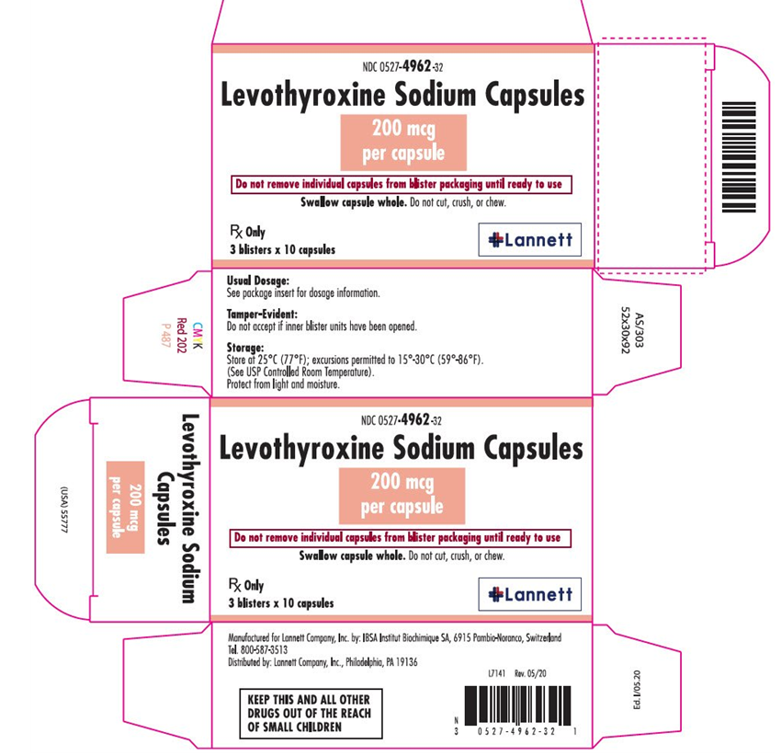

Figure:5 Label of Levothyroxine Capsule ^{[18]}
- DISCUSSION:
Hypothyroidism is a condition characterized by a deficiency of thyroid hormones, leading to a slowed metabolism. Hypothyroidism occurs when the thyroid gland produces insufficient thyroid hormones, leading to a slowed metabolism. Common symptoms include fatigue, weight gain, depression, and, if untreated, more severe health issues such as heart problems or infertility.Levothyroxine is a synthetic form of thyroid hormone used to treat hypothyroidism. While it helps normalize hormone levels. Liothyronine, another thyroid hormone treatment, contains the active form of thyroid hormone (T3). It may cause side effects like weight loss, headache, insomnia, rapid heartbeat, and diarrhea, particularly if the dosage is too high. Adjusting dosages carefully is key to minimizing side effects while treating hypothyroidism.

- CONCLUSION:
Levothyroxine helps maintain normal metabolic functions, regulate body temperature, and support heart, brain, and energy levels by restoring thyroid hormone balance. However, liothyronine may cause side effects such as weight loss, headache, insomnia, rapid heartbeat, and diarrhea. While generally safe and effective, careful dosing and monitoring are required to avoid the risks of over- or under-treatment. Levothyroxine is a cornerstone in the treatment of hypothyroidism and related conditions.

- REFERANCE:
1. Taylor PN, Albrecht D, Scholz A, Gutierrez-Buey G, Lazarus JH, Dayan CM, Okosieme OE. Global epidemiology of hyperthyroidism and hypothyroidism. Nat Rev Endocrinol. 2018 May;14(5):301-316. [PubMed]
2. Garber JR, Cobin RH, Gharib H, Hennessey JV, Klein I, Mechanick JI, Pessah-Pollack R, Singer PA, Woeber KA., American Association Of Clinical Endocrinologists And American Thyroid Association Taskforce On Hypothyroidism In Adults. Clinical practice guidelines for hypothyroidism in adults: cosponsored by the American Association of Clinical Endocrinologists and the American Thyroid Association. Thyroid. 2012 Dec;22(12):1200-35. [PubMed]
3. Jonklaas J, Bianco AC, Bauer AJ, Burman KD, Cappola AR, Celi FS, Cooper DS, Kim BW, Peeters RP, Rosenthal MS, Sawka AM., American Thyroid Association Task Force on Thyroid Hormone Replacement. Guidelines for the treatment of hypothyroidism: prepared by the american thyroid association task force on thyroid hormone replacement. Thyroid. 2014 Dec;24(12):1670-751. [PMC free article] [PubMed]
4. Peng CC, Pearce EN. An update on thyroid disorders in the postpartum period. J Endocrinol Invest. 2022 Aug;45(8):1497-1506. [PubMed]
5. Phowira J, Coffey KL, Bartholomew PH, Vennart N, Moreira M, Emerson H, Kennedy D, Weaver JU. Radioactive Iodine for the Treatment of Subclinical Thyrotoxicosis Grade 1 and 2: Outcome of up to 18-Year Follow Up. Front Endocrinol (Lausanne). 2022;13:843857. [PMC free article] [PubMed]
6. Cooper DS, Halpern R, Wood LC, Levin AA, Ridgway EC. L-Thyroxine therapy in subclinical hypothyroidism. A double-blind, placebo-controlled trial. Ann Intern Med. 1984 Jul;101(1):18-24. [PubMed]
7. Chaker L, Bianco AC, Jonklaas J, Peeters RP. Hypothyroidism. Lancet. 2017 Sep 23;390(10101):1550-1562. [PMC free article] [PubMed]
8. Haugen BR, Alexander EK, Bible KC, Doherty GM, Mandel SJ, Nikiforov YE, Pacini F, Randolph GW, Sawka AM, Schlumberger M, Schuff KG, Sherman SI, Sosa JA, Steward DL, Tuttle RM, Wartofsky L. 2015 American Thyroid Association Management Guidelines for Adult Patients with Thyroid Nodules and Differentiated Thyroid Cancer: The American Thyroid Association Guidelines Task Force on Thyroid Nodules and Differentiated Thyroid Cancer. Thyroid. 2016 Jan;26(1):1-133. [PMC free article] [PubMed]
9. Ono Y, Ono S, Yasunaga H, Matsui H, Fushimi K, Tanaka Y. Clinical characteristics and outcomes of myxedema coma: Analysis of a national inpatient database in Japan. J Epidemiol. 2017 Mar;27(3):117-122. [PMC free article] [PubMed]
10. Salim A, Vassiliu P, Velmahos GC, Sava J, Murray JA, Belzberg H, Asensio JA, Demetriades D. The role of thyroid hormone administration in potential organ donors. Arch Surg. 2001 Dec;136(12):1377-80. [PubMed]
11. Laniro G, Mangiola F, Di Rienzo TA, Bibbò S, Franceschi F, Greco AV, Gasbarrini A. Levothyroxine absorption in health and disease, and new therapeutic perspectives. Eur Rev Med Pharmacol Sci. 2014;18(4):451-6. [PubMed]
12. Kashiwagura Y, Uchida S, Tanaka S, Watanabe H, Masuzawa M, Sasaki T, Namiki N. Clinical efficacy and pharmacokinetics of levothyroxine suppository in patients with hypothyroidism. Biol Pharm Bull. 2014;37(4):666-70. [PubMed]
13.Figure of Levothyroxine tablet https://www.bing.com/images/search?view=detailV2&ccid=N8NLBBwx&id=619166DDFFABE3B09349D77718A64E194AFC5245&thid=OIP.N8NLBBwxk-6hH4liR2rCVwHaE7&mediaurl=https%3a%2f%2fassets.treated.com%2fproductimages%2flevothyroxine-Tablets-25mcg-
14. Khalid S, Asad-Ur-Rahman F, Abbass A, Gordon D, Abusaada K. Myxedema Ascites: A Rare Presentation of Uncontrolled Hypothyroidism. Cureus. 2016 Dec 05;8(12):e912. [PMC free article] [PubMed]
15.Saini V, Yadav A, Arora MK, Arora S, Singh R, Bhattacharjee J. Correlation of creatinine with TSH levels in overt hypothyroidism - a requirement for monitoring of renal function in hypothyroid patients? Clin Biochem. 2012 Feb;45(3):212-4. [PubMed]
16.Jonklaas J. Optimal Thyroid Hormone Replacement. Endocr Rev. 2022 Mar 09;43(2):366-404. [PMC free article] [PubMed]
17.Barlow BT, Roberts RJ, Newman K, Harrison SK, Sin JH. Economic Evaluation of a Pharmacist-Led 5-Day Therapeutic Hold of IV Levothyroxine at an Academic Medical Center. Hosp Pharm. 2022 Feb;57(1):20-25. [PMC free article] [PubMed]
18.Antonelli A, Elia G, Ragusa F, Paparo SR, Cavallini G, Benvenga S, Ferrari SM, Fallahi P. The Stability of TSH, and Thyroid Hormones, in Patients Treated With Tablet, or Liquid Levo-Thyroxine. Front Endocrinol (Lausanne). 2021;12:633587. [PMC free article] [PubMed]

